Enterprise Network 2350

Lab 4.1.1a Policy Implementation

GYIMP

Jacob Calvert, Timothy Zellers, Regan Stubbs, James Baker, Faustino Gonzales

Criteria #1: Guest Policy (scope=users) Written policy section & configuration proof.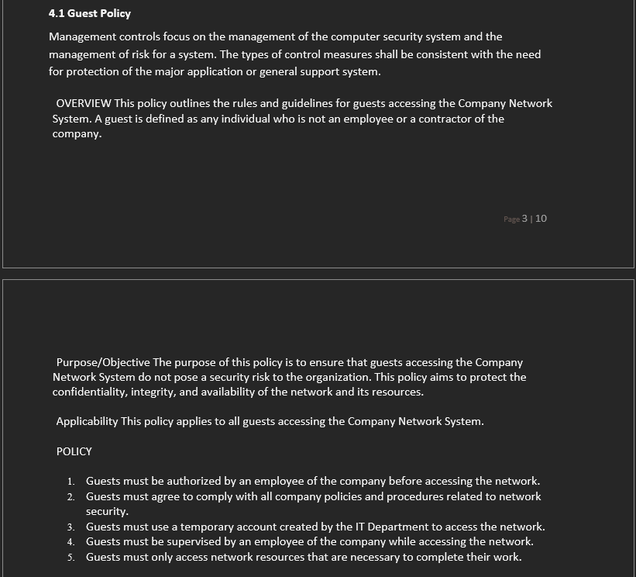

Criteria #2: Authentication / Password Policy applied “GPO” (scope=users) Written policy section & configuration proof.

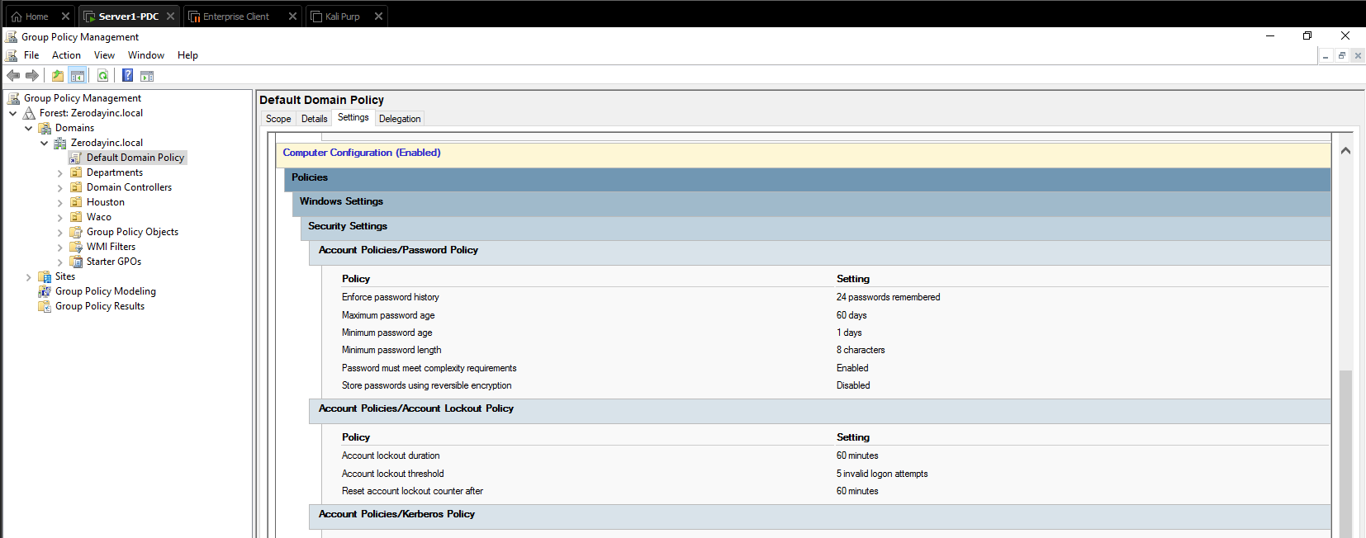

Criteria #3: Network Security Policy – Wireless (scope=users) Written policy section & configuration proof in packet tracer.

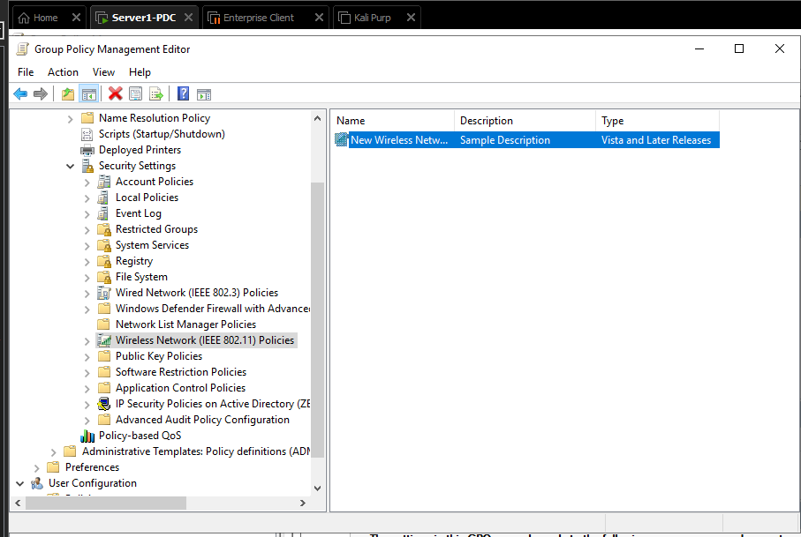

Criteria #4: Network Security Policy - Firewall & ACL (scope=IT) Written policy section & configuration proof in packet tracer.

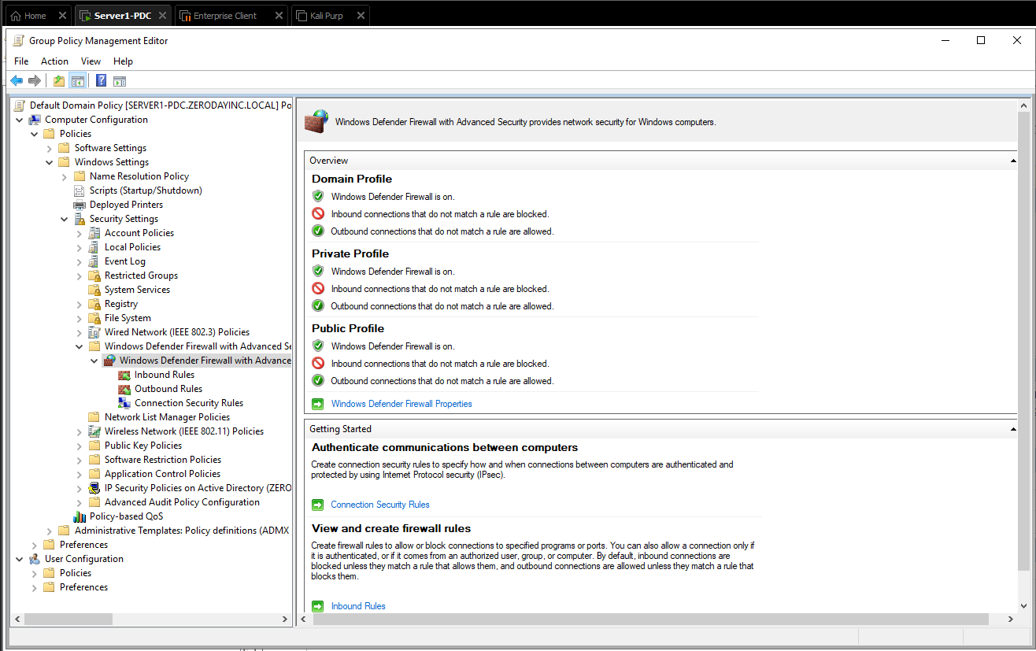

Criteria #5: Remote Access: Encryption (scope=IT) Written policy section & configuration proof.

